SIMPLIFIED
BOMB DEFUSAL
MANUAL

bombmanual.ainyaku.com

Version 1.3
Verification Code: 241

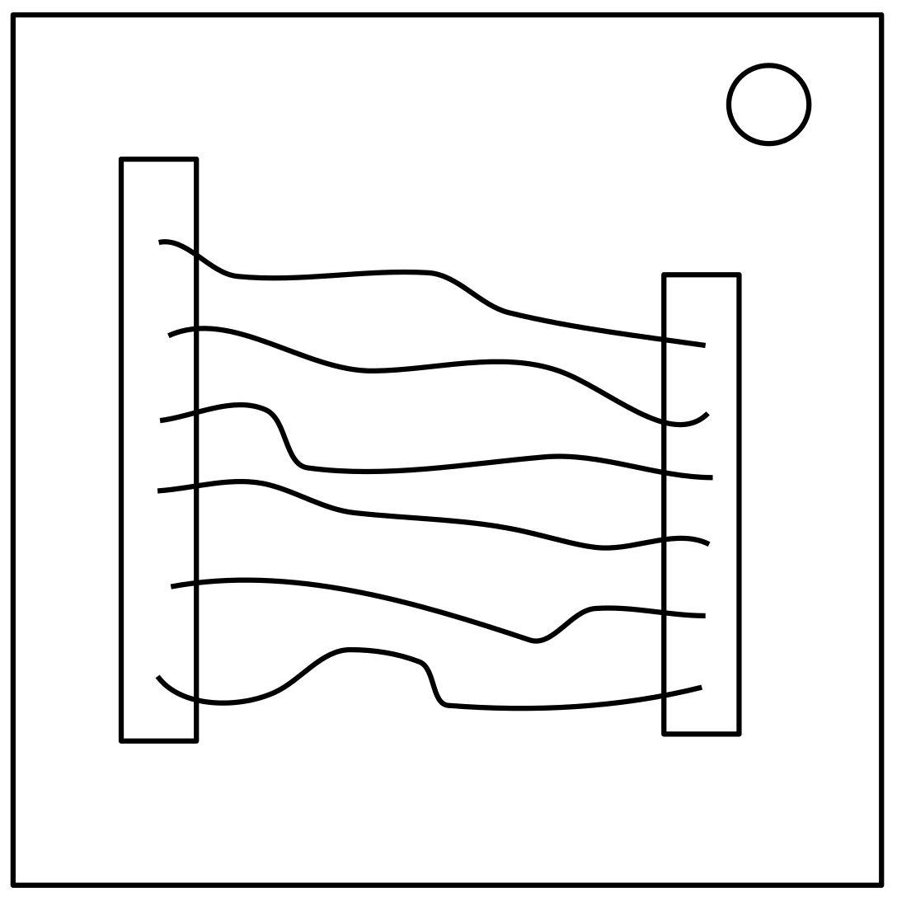
Wires

- One of the wires on this module needs to be cut.
- Refer to the chart below to decide which wire needs to be cut.
- Wire ordering begins with the first on the top.
- Refer to the appendix for where to find serial numbers.

There are 3 wires | There are no red wires | Cut the second wire
 | The last wire is white | Cut the last wire
 | There is more than one blue wire | Cut the last blue wire
 | Otherwise | Cut the last wire
There are 4 wires | There is more than one red wire and the last digit of the serial number is odd | Cut the last red wire
 | The last wire is yellow and there are no red wires | Cut the first wire
 | There is exactly one blue wire
 | There is more than one yellow wire | Cut the last wire
 | Otherwise | Cut the second wire
There are 5 wires | The last wire is black and the last digit of the serial number is odd | Cut the fourth wire
 | There is exactly one red wire and there is more than one yellow wire | Cut the first wire
 | There are no black wires | Cut the second wire
 | Otherwise | Cut the first wire
There are 6 wires | There are no yellow wires and the last digit of the serial number is odd | Cut the third wire
 | There is exactly one yellow wire and there is more than one white wire | Cut the fourth wire
 | There are no red wires | Cut the last wire
 | Otherwise | Cut the fourth wire

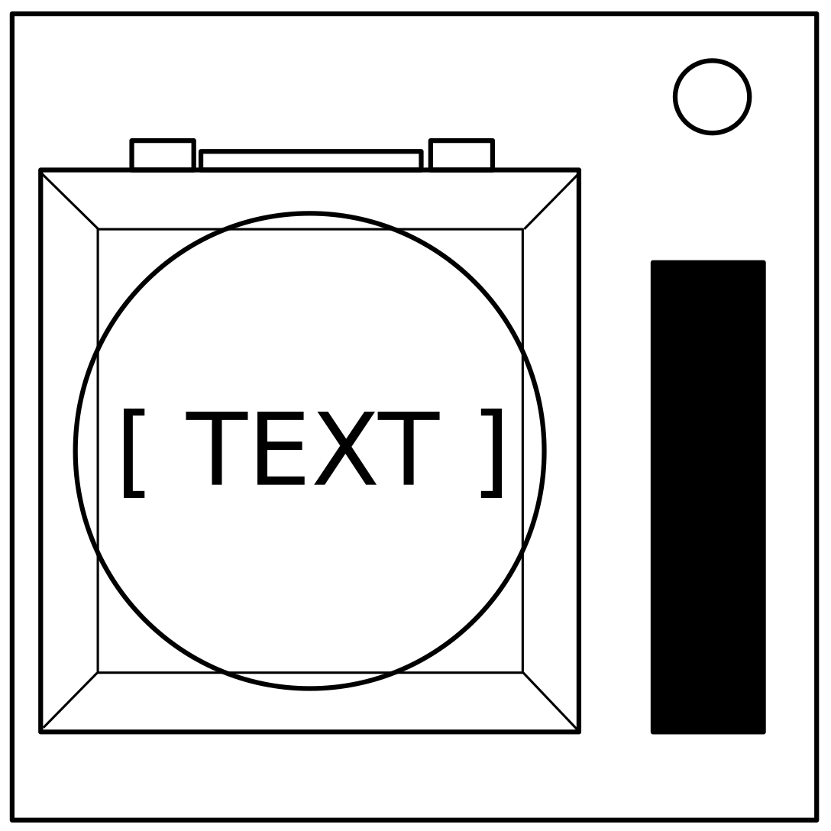
Buttons

- Follow these rules below in the order they are listed from top to bottom. Perform the first action that applies.
- If one of the rules applies, refer to the box of the same color on the right (or follow the lines if printed in black and white).
- Refer to the appendix for where to find batteries and indicators.

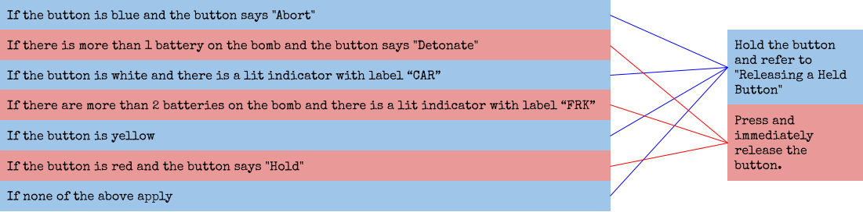

Releasing a Held Button
If you start holding the button down, a colored strip will light up on the right side of the module. Based on its color, you must release the button at a specific point in time.
- Blue strip: release when the countdown timer has a 4 in any position.
- Yellow strip: release when the countdown timer has a 5 in any position.
- Red or white strip: release when the countdown timer has a 1 in any position.

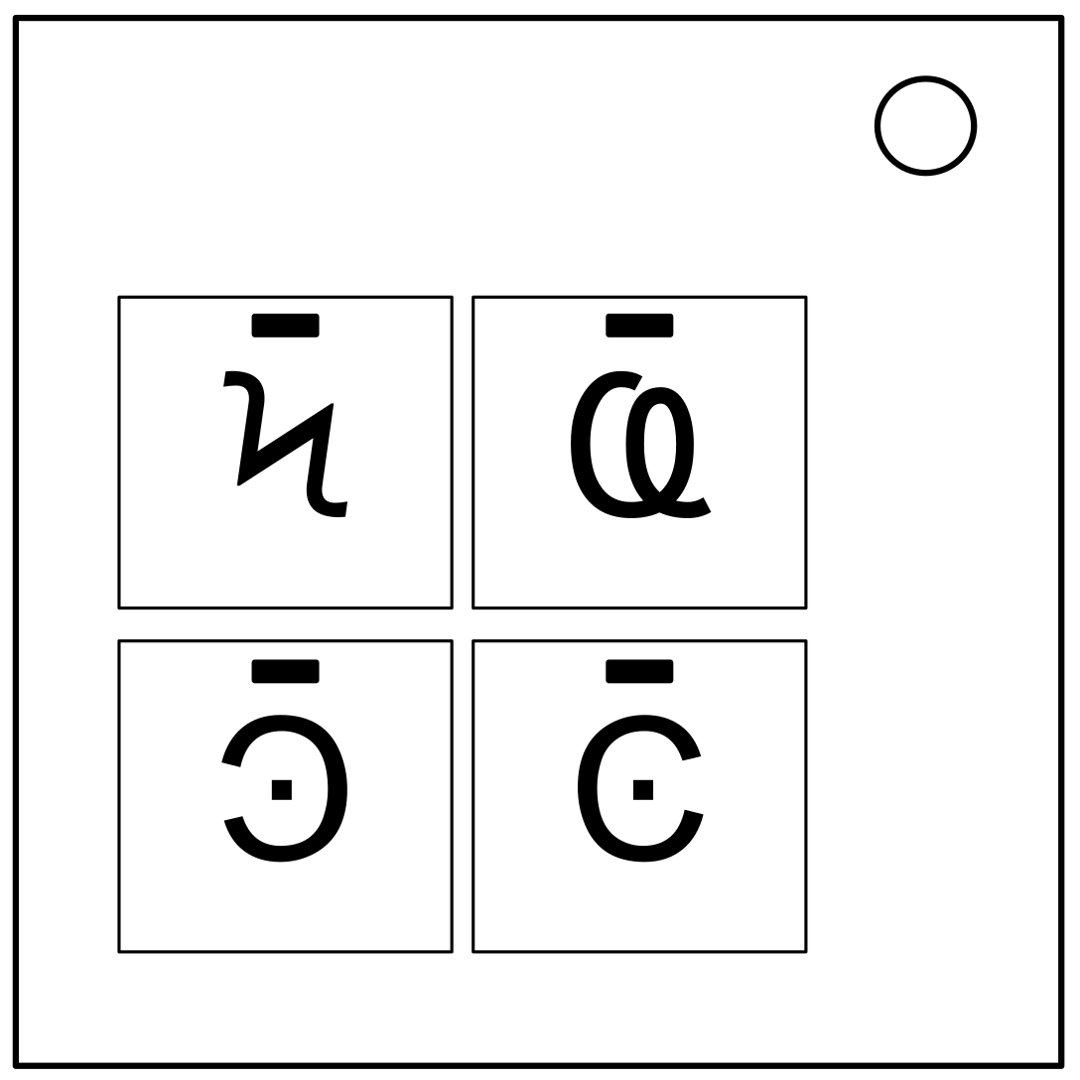
Symbols
aka keypads

- Only one column below has all four of the symbols from the keypad.
- Press the four buttons in the order their symbols appear from top to bottom within that column.
* Try to describe the symbols by relating them to real objects.

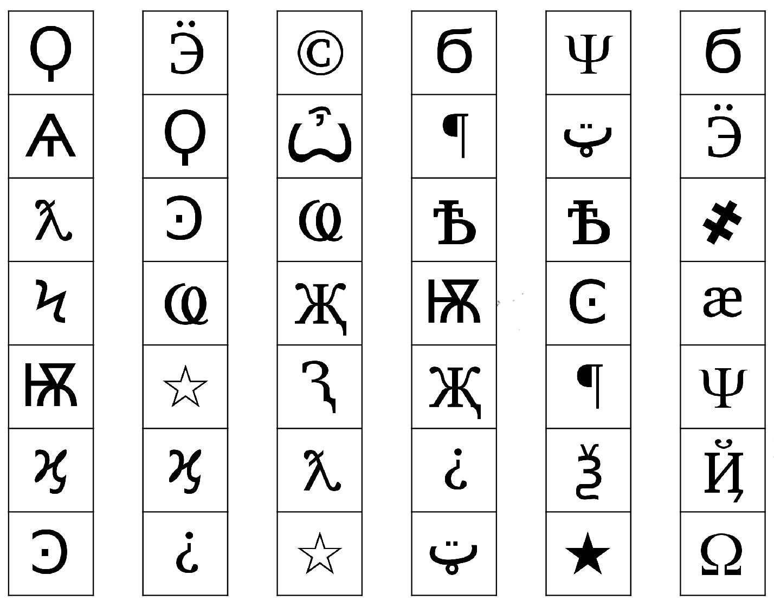

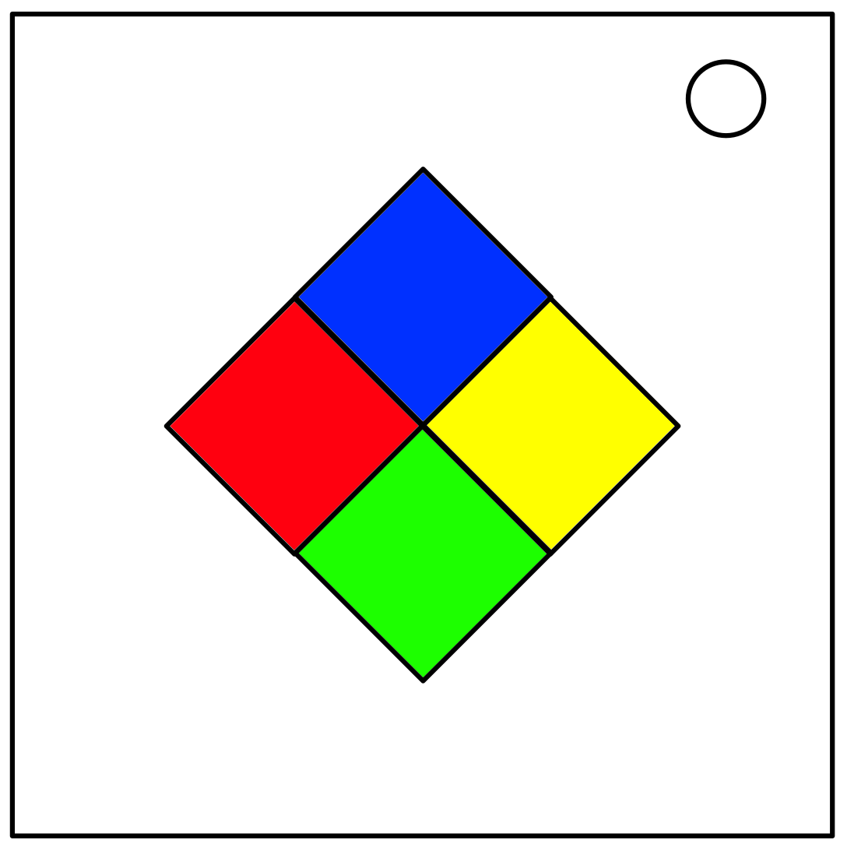
Simon Says

- One of the four colored buttons will flash.
- Use the table below to choose which button should be pressed.
- The sequence will lengthen by one each time you correctly enter a sequence.
- Keep pressing the buttons until the module is disarmed.
- Refer to the appendix for where to find serial numbers.

 |  | Red Flash | Blue Flash | Green Flash | Yellow Flash
Serial number has a vowel | No Strikes | Blue | Red | Yellow | Green
 | 1 Strike | Yellow | Green | Blue | Red
 | 2 Strikes | Green | Red | Yellow | Blue
Serial number has no vowel | No Strikes | Blue | Yellow | Green | Red
 | 1 Strike | Red | Blue | Yellow | Green
 | 2 Strikes | Yellow | Green | Blue | Red

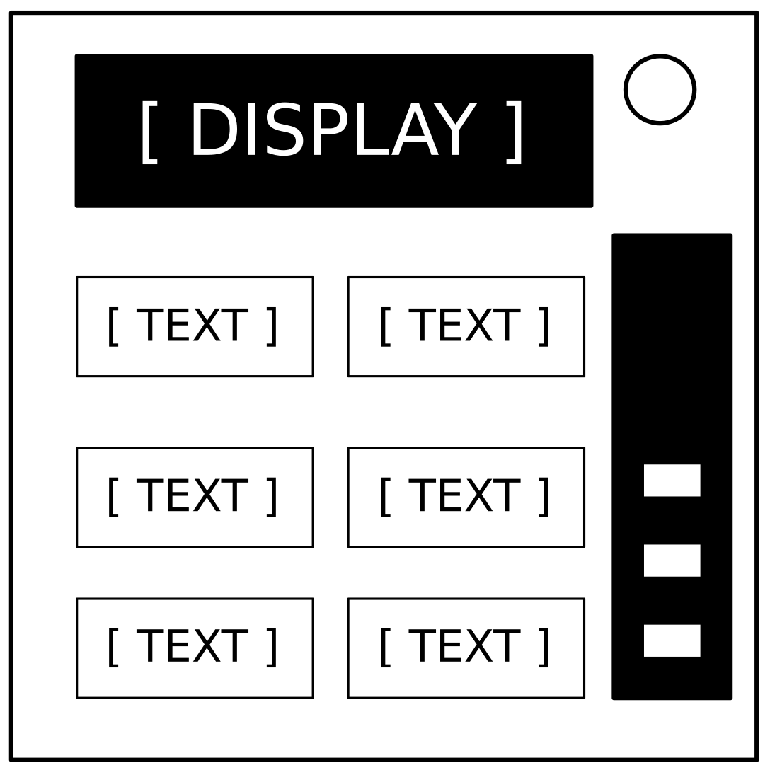
Word Module
aka who’s on first

- Ask the defuser to read the word on the display. *
- Find that word in one of the tables below. **
- Ask the defuser to read the word in the space with the eye on it. *
- Find that word on the chart on the next page. **
- Tell the defuser to press the first word that appears on the list next to that word. *
- Repeat until the module has been disarmed.
* Make sure to spell the word to prevent confusion.
** Some of the words on this document are in alphabetical order so you can find the
word easier.

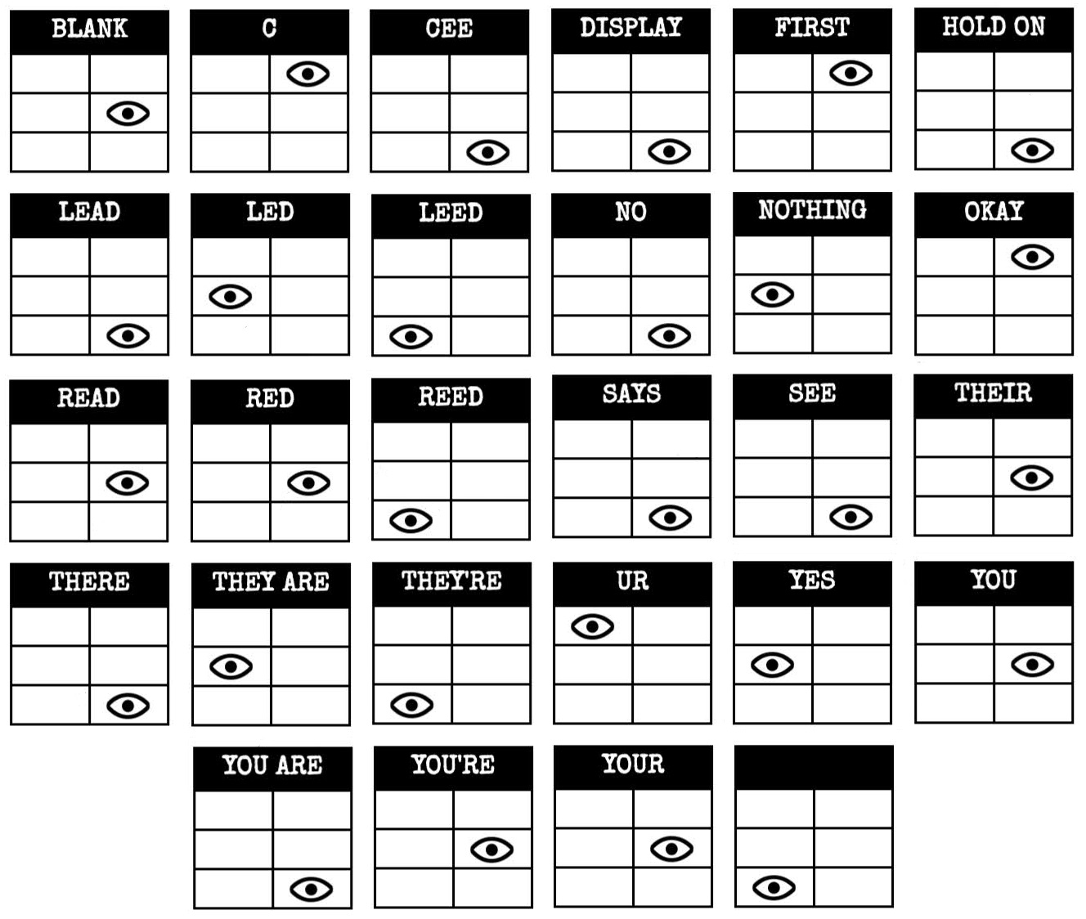

BLANK | WAIT, RIGHT, OKAY, MIDDLE, BLANK, PRESS, READY, NOTHING, NO, WHAT, LEFT, UHHH, YES, FIRST
DONE | SURE, UH HUH, NEXT, WHAT?, YOUR, UR, YOU'RE, HOLD, LIKE, YOU, U, YOU ARE, UH UH, DONE
FIRST | LEFT, OKAY, YES, MIDDLE, NO, RIGHT, NOTHING, UHHH, WAIT, READY, BLANK, WHAT, PRESS, FIRST
HOLD | YOU ARE, U, DONE, UH UH, YOU, UR, SURE, WHAT?, YOU'RE, NEXT, HOLD, UH HUH, YOUR, LIKE
LEFT | RIGHT, LEFT, FIRST, NO, MIDDLE, YES, BLANK, WHAT, UHHH, WAIT, PRESS, READY, OKAY, NOTHING
LIKE | YOU'RE, NEXT, U, UR, HOLD, DONE, UH UH, WHAT?, UH HUH, YOU, LIKE, SURE, YOU ARE, YOUR
MIDDLE | BLANK, READY, OKAY, WHAT, NOTHING, PRESS, NO, WAIT, LEFT, MIDDLE, RIGHT, FIRST, UHHH, YES
NEXT | WHAT?, UH HUH, UH UH, YOUR, HOLD, SURE, NEXT, LIKE, DONE, YOU ARE, UR, YOU'RE, U, YOU
NO | BLANK, UHHH, WAIT, FIRST, WHAT, READY, RIGHT, YES, NOTHING, LEFT, PRESS, OKAY, NO, MIDDLE
NOTHING | UHHH, RIGHT, OKAY, MIDDLE, YES, BLANK, NO, PRESS, LEFT, WHAT, WAIT, FIRST, NOTHING, READY
OKAY | MIDDLE, NO, FIRST, YES, UHHH, NOTHING, WAIT, OKAY, LEFT, READY, BLANK, PRESS, WHAT, RIGHT
PRESS | RIGHT, MIDDLE, YES, READY, PRESS, OKAY, NOTHING, UHHH, BLANK, LEFT, FIRST, WHAT, NO, WAIT
READY | YES, OKAY, WHAT, MIDDLE, LEFT, PRESS, RIGHT, BLANK, READY, NO, FIRST, UHHH, NOTHING, WAIT
RIGHT | YES, NOTHING, READY, PRESS, NO, WAIT, WHAT, RIGHT, MIDDLE, LEFT, UHHH, BLANK, OKAY, FIRST
SURE | YOU ARE, DONE, LIKE, YOU'RE, YOU, HOLD, UH HUH, UR, SURE, U, WHAT?, NEXT, YOUR, UH UH
U | UH HUH, SURE, NEXT, WHAT?, YOU'RE, UR, UH UH, DONE, U, YOU, LIKE, HOLD, YOU ARE, YOUR
UH HUH | UH HUH, YOUR, YOU ARE, YOU, DONE, HOLD, UH UH, NEXT, SURE, LIKE, YOU'RE, UR, U, WHAT?
UH UH | UR, U, YOU ARE, YOU'RE, NEXT, UH UH, DONE, YOU, UH HUH, LIKE, YOUR, SURE, HOLD, WHAT?
UHHH | READY, NOTHING, LEFT, WHAT, OKAY, YES, RIGHT, NO, PRESS, BLANK, UHHH, MIDDLE, WAIT, FIRST
UR | DONE, U, UR, UH HUH, WHAT?, SURE, YOUR, HOLD, YOU'RE, LIKE, NEXT, UH UH, YOU ARE, YOU
WAIT | UHHH, NO, BLANK, OKAY, YES, LEFT, FIRST, PRESS, WHAT, WAIT, NOTHING, READY, RIGHT, MIDDLE
WHAT | UHHH, WHAT, LEFT, NOTHING, READY, BLANK, MIDDLE, NO, OKAY, FIRST, WAIT, YES, PRESS, RIGHT
WHAT? | YOU, HOLD, YOU'RE, YOUR, U, DONE, UH UH, LIKE, YOU ARE, UH HUH, UR, NEXT, WHAT?, SURE
YES | OKAY, RIGHT, UHHH, MIDDLE, FIRST, WHAT, PRESS, READY, NOTHING, YES, LEFT, BLANK, NO, WAIT
YOU | SURE, YOU ARE, YOUR, YOU'RE, NEXT, UH HUH, UR, HOLD, WHAT?, YOU, UH UH, LIKE, DONE, U
YOU ARE | YOUR, NEXT, LIKE, UH HUH, WHAT?, DONE, UH UH, HOLD, YOU, U, YOU'RE, SURE, UR, YOU ARE
YOU'RE | YOU, YOU'RE, UR, NEXT, UH UH, YOU ARE, U, YOUR, WHAT?, UH HUH, SURE, DONE, LIKE, HOLD
YOUR | UH UH, YOU ARE, UH HUH, YOUR, NEXT, UR, SURE, U, YOU'RE, YOU, WHAT?, HOLD, LIKE, DONE

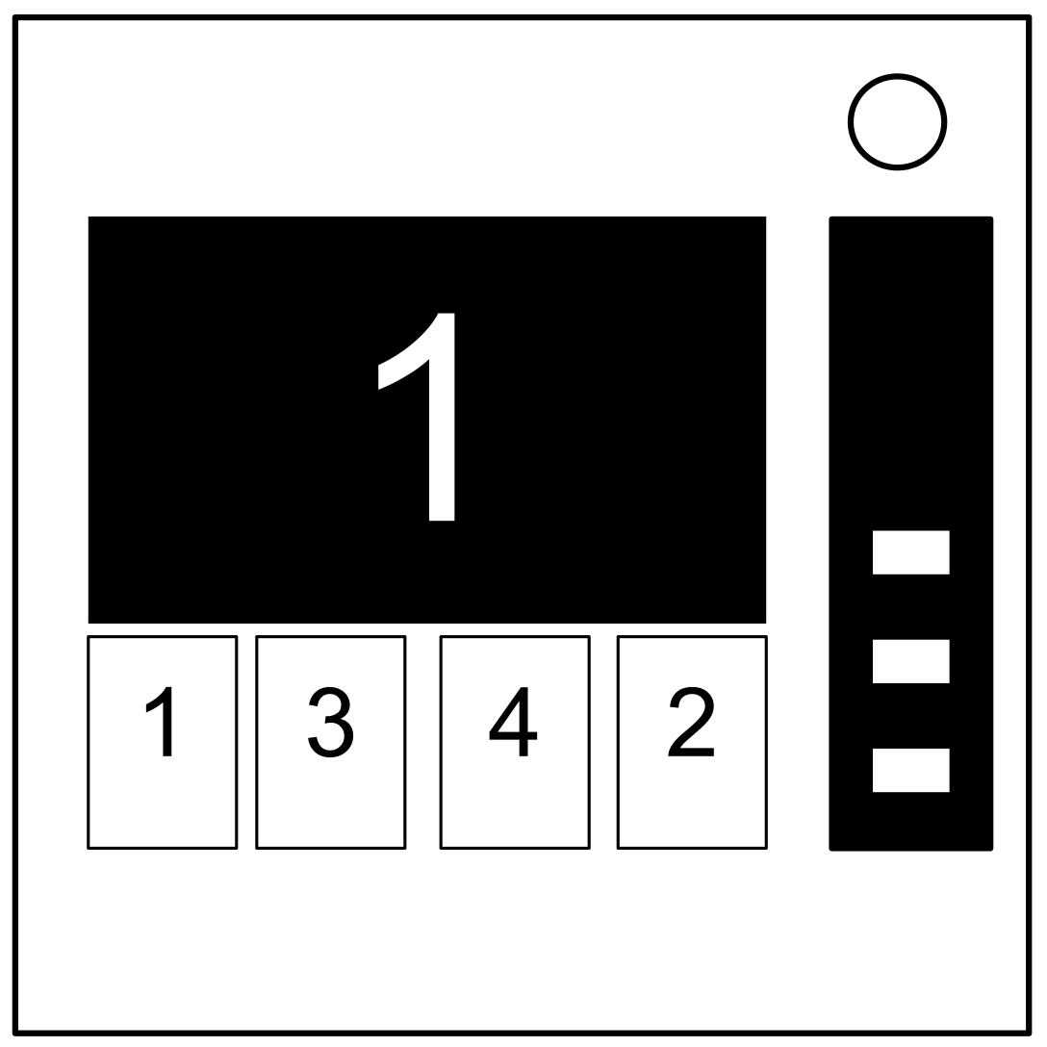
Number Module
aka memory

- One of the 4 buttons on this module needs to be pressed.
- Use the table below to figure out which button is the correct one.
- Complete all 5 stages to disarm the module.
- Pressing an incorrect button will reset the module back to stage 1.
- Button positions are ordered from left to right.
* Make sure to write down the position and label of each button pressed just in
case it is needed later on.

Stage 1 | If the display is 1 | Press the button in the second position
 | If the display is 2
 | If the display is 3 | Press the button in the third position
 | If the display is 4 | Press the button in the fourth position
Stage 2 | If the display is 1 | Press the button labeled "4"
 | If the display is 2 | Press the button in the same position as you pressed in stage 1
 | If the display is 3 | Press the button in the first position
 | If the display is 4 | Press the button in the same position as you pressed in stage 1
Stage 3 | If the display is 1 | Press the button with the same label you pressed in stage 2
 | If the display is 2 | Press the button with the same label you pressed in stage 1
 | If the display is 3 | Press the button in the third position
 | If the display is 4 | Press the button labeled "4"
Stage 4 | If the display is 1 | Press the button in the same position as you pressed in stage 1
 | If the display is 2 | Press the button in the first position
 | If the display is 3 | Press the button in the same position as you pressed in stage 2
 | If the display is 4
Stage 5 | If the display is 1 | Press the button with the same label you pressed in stage 1
 | If the display is 2 | Press the button with the same label you pressed in stage 2
 | If the display is 3 | Press the button with the same label you pressed in stage 4
 | If the display is 4 | Press the button with the same label you pressed in stage 3

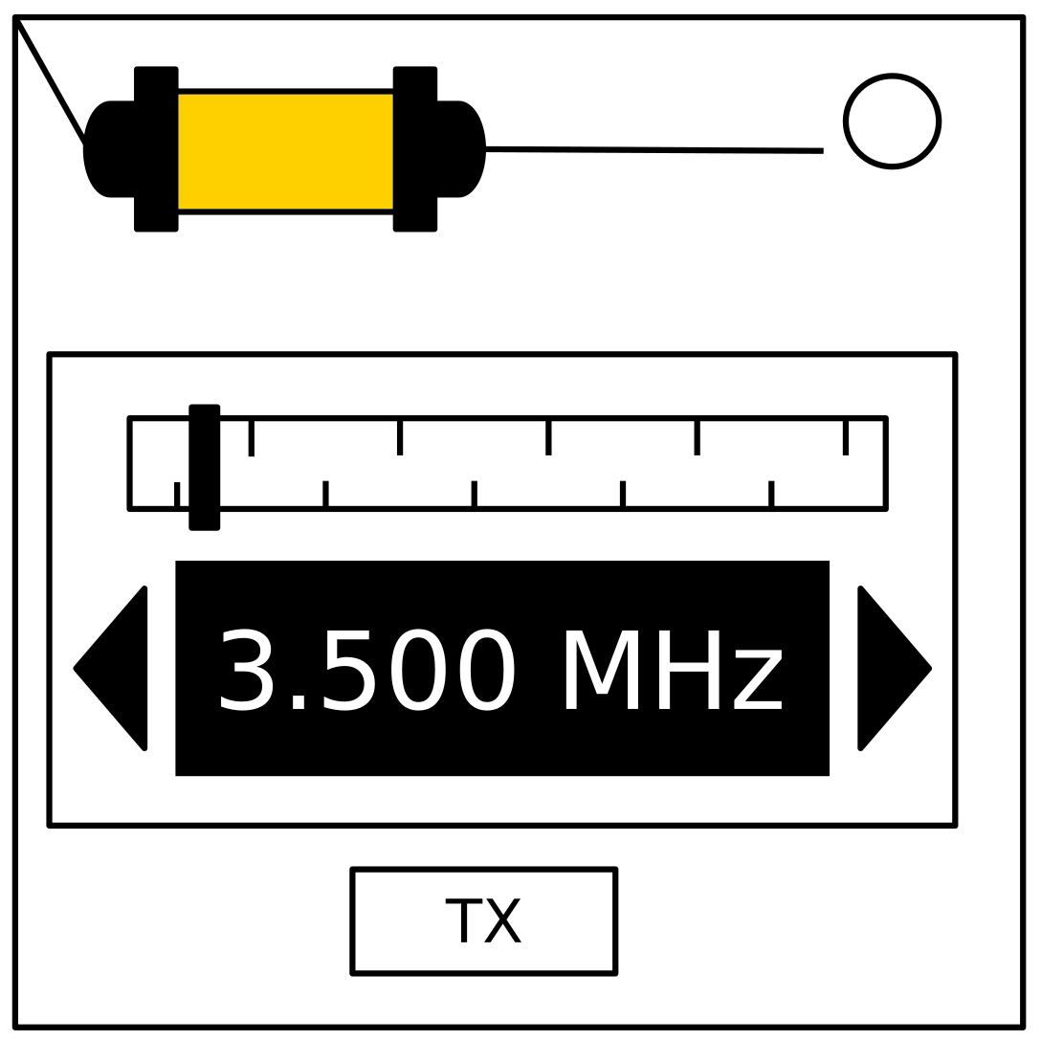
Morse Code

- On this module, there will be a flashing light.
- Use the chart below to spell one of the words in the table. *
- A short flash represents a dot.
- A long flash represents a dash.
- There is a long gap between letters.
- There is a very long gap before the word repeats.
- Once the word is identified, set the corresponding frequency and press the transmit (TX) button.
* Instead of using the chart, you may find a morse code keyboard easier to use.

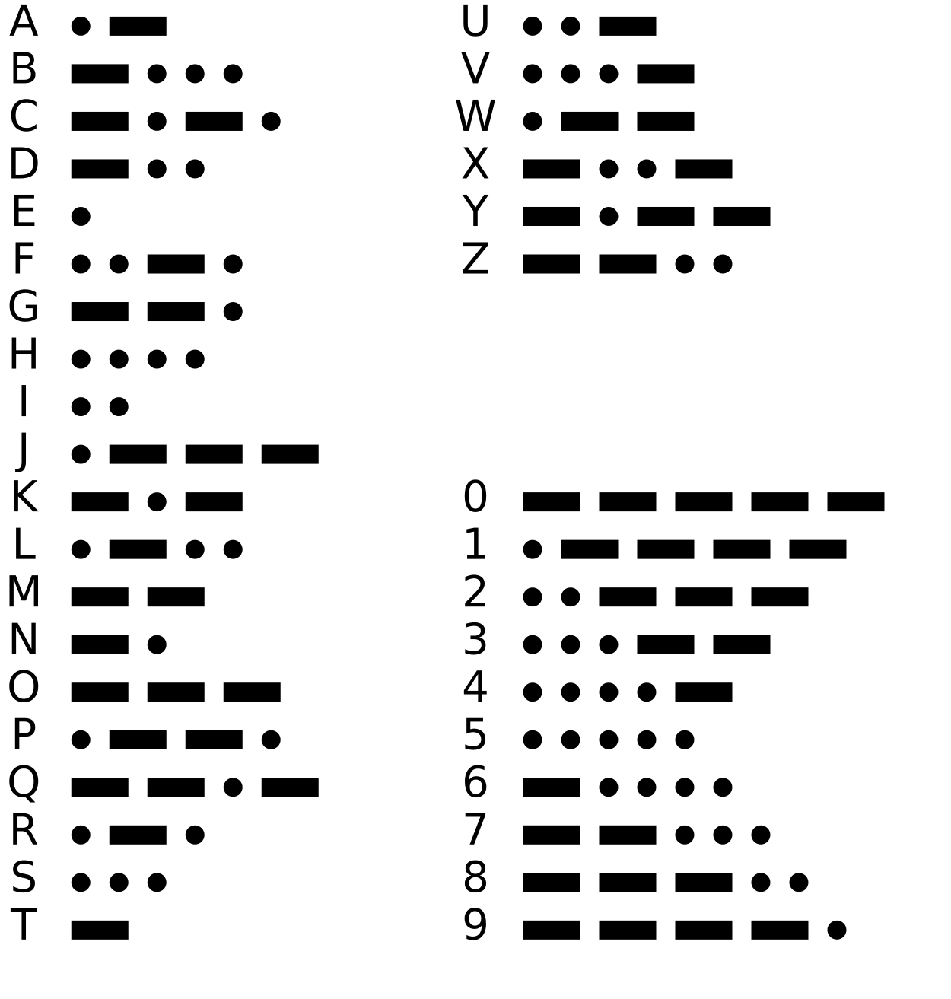 | If the word is | Respond at frequency
 | beats | 3.505 MHz
 | bistro | 3.552 MHz
 | bombs | 3.565 MHz
 | boxes | 3.535 MHz
 | break | 3.572 MHz
 | brick | 3.575 MHz
 | flick | 3.555 MHz
 | halls | 3.515 MHz
 | leaks | 3.542 MHz
 | shell | 3.505 MHz
 | slick | 3.522 MHz
 | steak | 3.582 MHz
 | sting | 3.592 MHz
 | strobe | 3.545 MHz
 | trick | 3.532 MHz
 | vector | 3.595 MHz

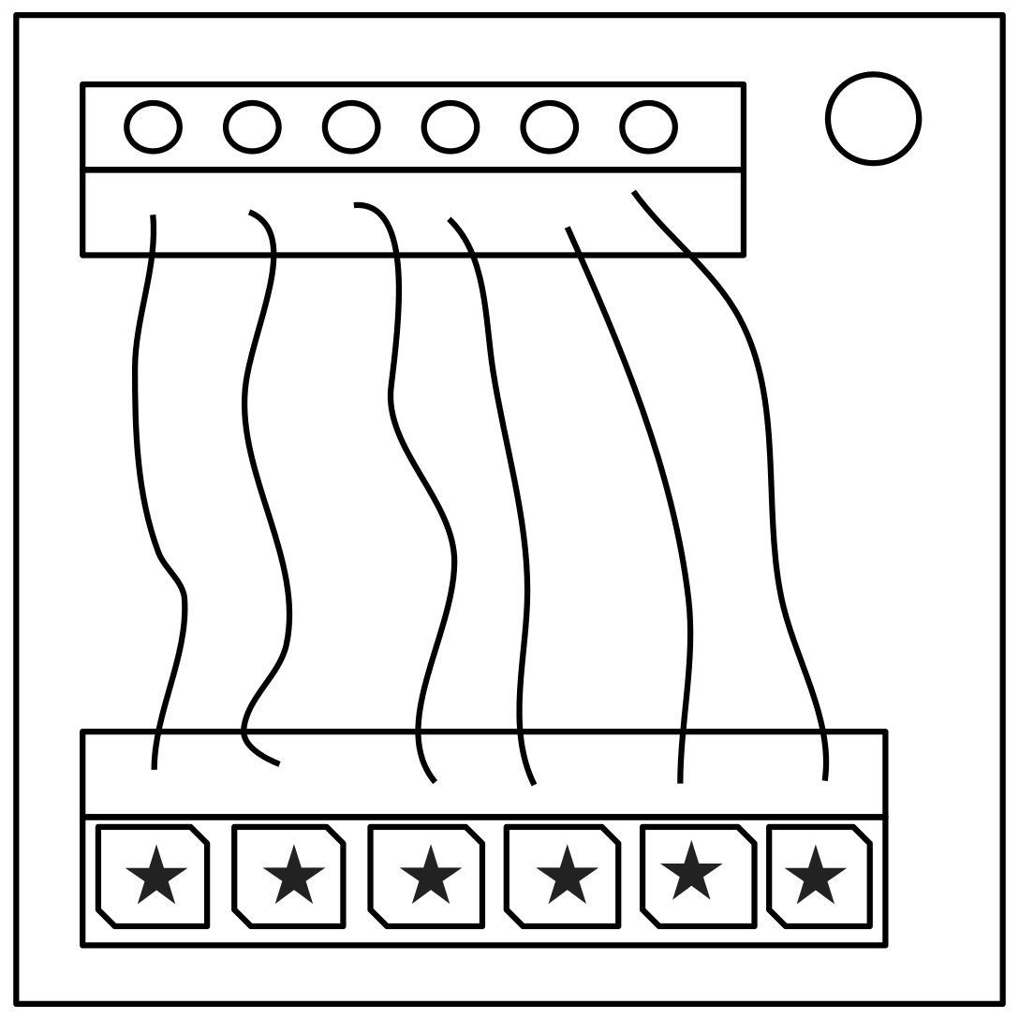
Complicated Wires

- On each wire, there is an LED above the wire and a space for a star symbol below the wire.
- For each wire in this module, use the diagram below to decide whether or not to cut the wire. *
- Some wires may be striped with multiple colors.
- Refer to the appendix for where to find batteries, parallel ports, and serial numbers.
* All right arrows mean true and all left arrows mean false.
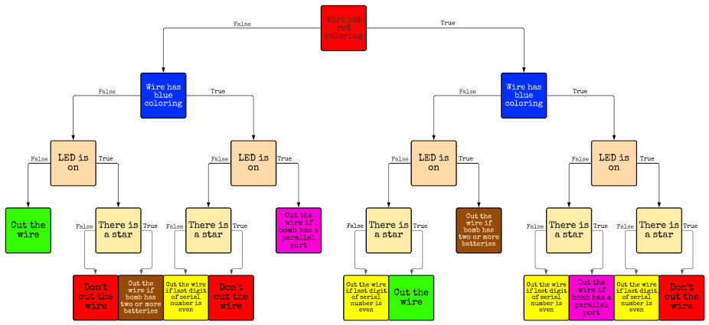
* If you can not see the chart well, here are the 9 types of squares:
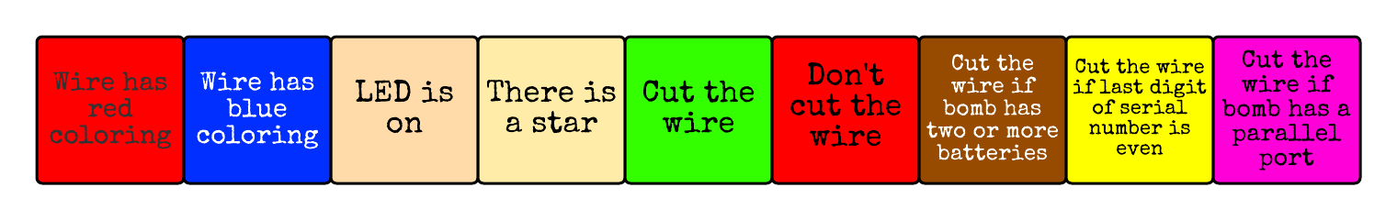

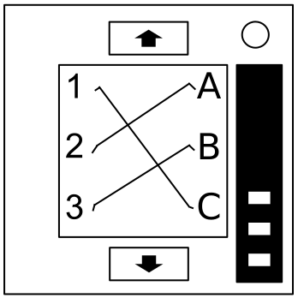
Wire Panels
aka wire sequences

- Within this module, there are several panels with wires on them.
- Use the chart below to decide which wires should be cut on each panel.
- Do not switch to the next panel until you are sure that you have cut all necessary wires on the current panel, but you can go back at any time.
- The number of wire occurrences adds up over all panels within the module.

Red Wire Occurrences |  | Blue Wire Occurrences |  | Black Wire Occurrences
Wire  Occurrence | Cut if  connected to | Wire  Occurrence | Cut if  connected to | Wire  Occurrence | Cut if  connected to
First red  occurrence | C | First blue  occurrence | B | First black  occurrence | Any wire
Second red  occurrence | B | Second blue  occurrence | A or C | Second black  occurrence | A or C
Third red  occurrence | A | Third blue  occurrence | B | Third black  occurrence | B
Fourth red  occurrence | A or C | Fourth blue  occurrence | A | Fourth black  occurrence | A or C
Fifth red  occurrence | B | Fifth blue  occurrence | B | Fifth black  occurrence | B
Sixth red  occurrence | A or C | Sixth blue  occurrence | B or C | Sixth black  occurrence | B or C
Seventh red  occurrence | Any wire | Seventh blue  occurrence | C | Seventh  black occurrence | A or B
Eighth red  occurrence | A or B | Eighth blue  occurrence | A or C | Eighth black  occurrence | C
Ninth red  occurrence | B | Ninth blue  occurrence | A | Ninth black  occurrence | C

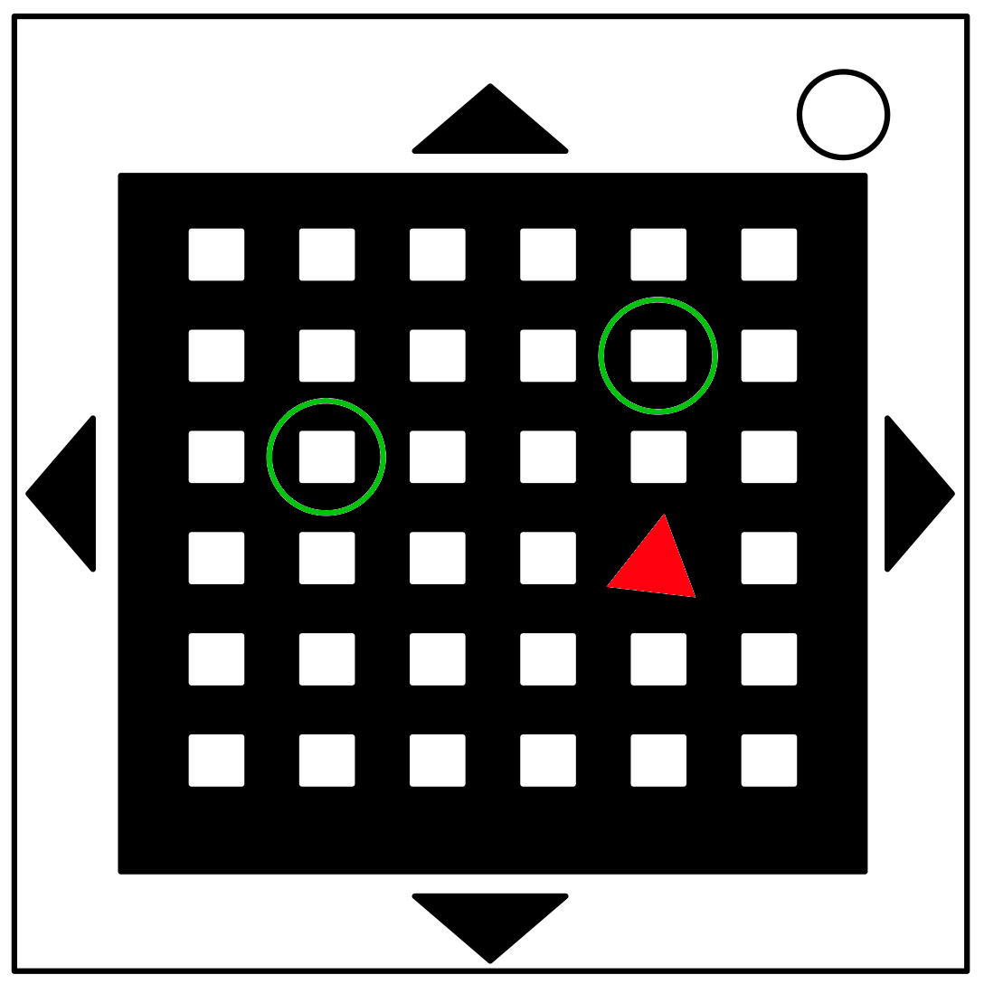
Mazes

- Find the maze with matching circular markings.
- The defuser must navigate the white dot to the red triangle using the arrow buttons without touching the lines (the white dot can touch the circles though).
- The defuser cannot see the lines.

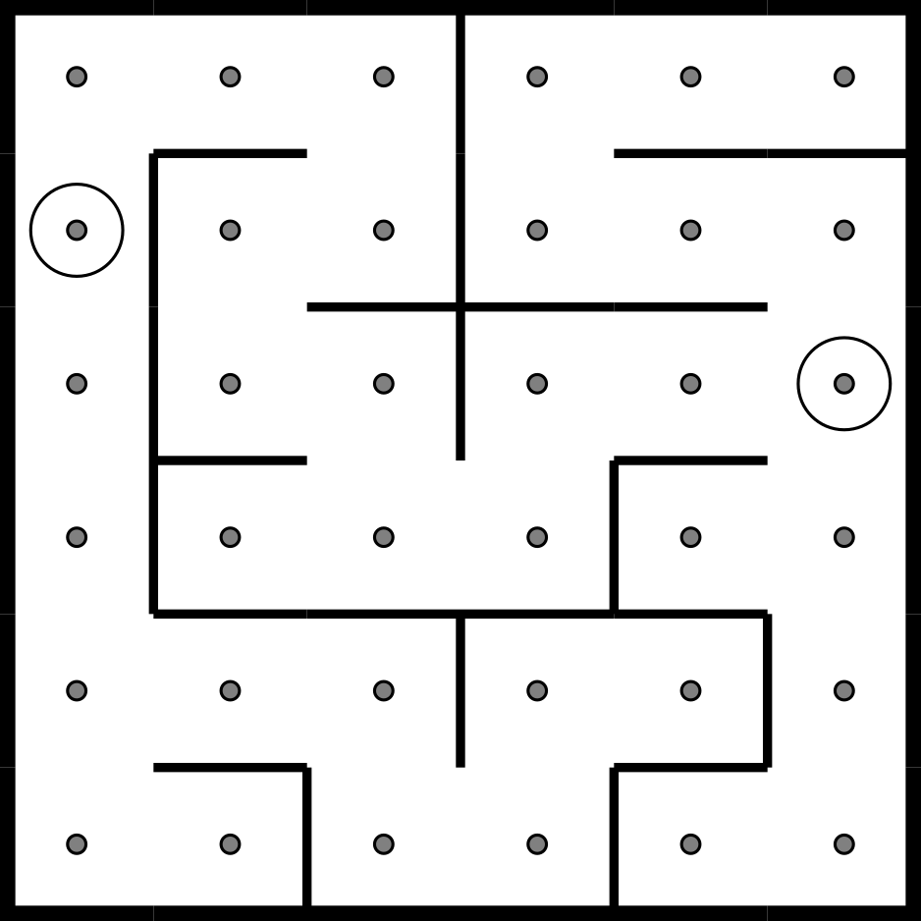 | 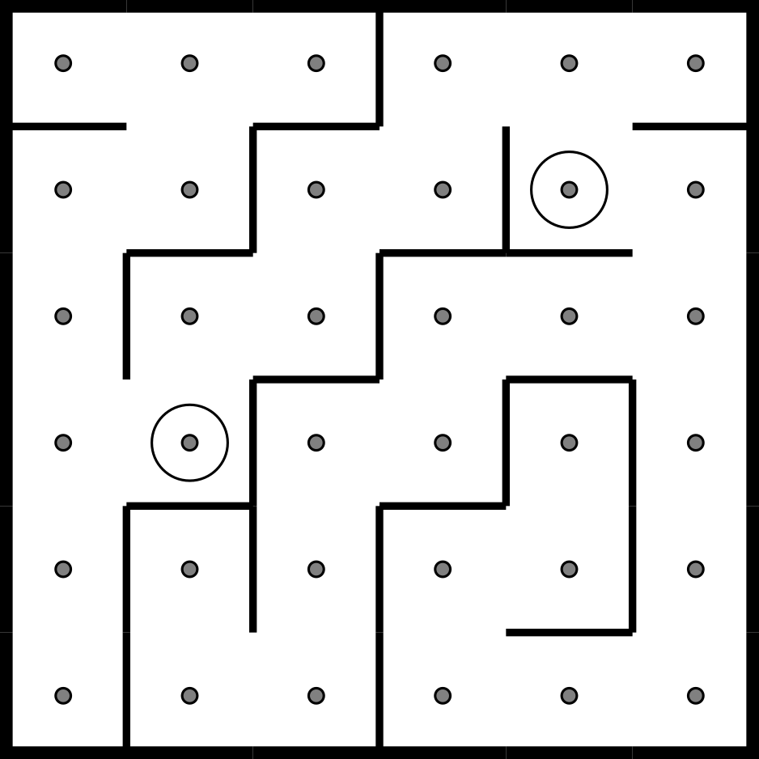 | 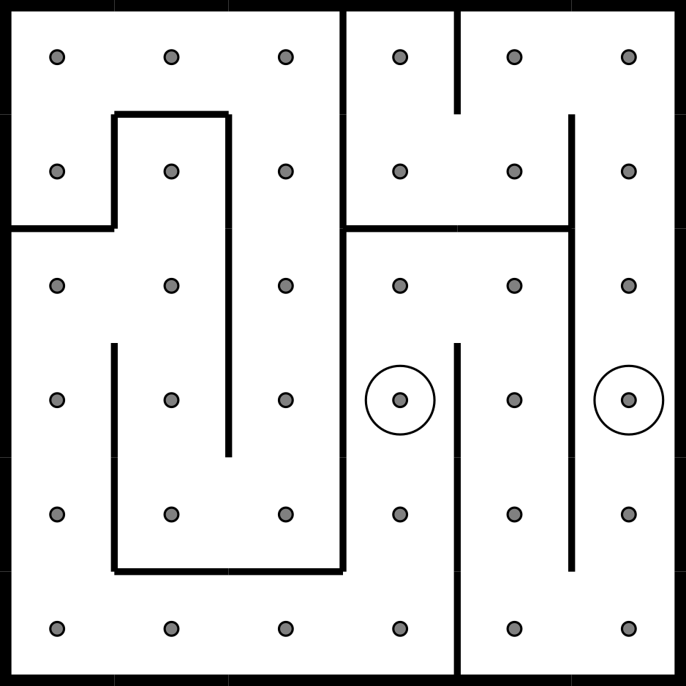
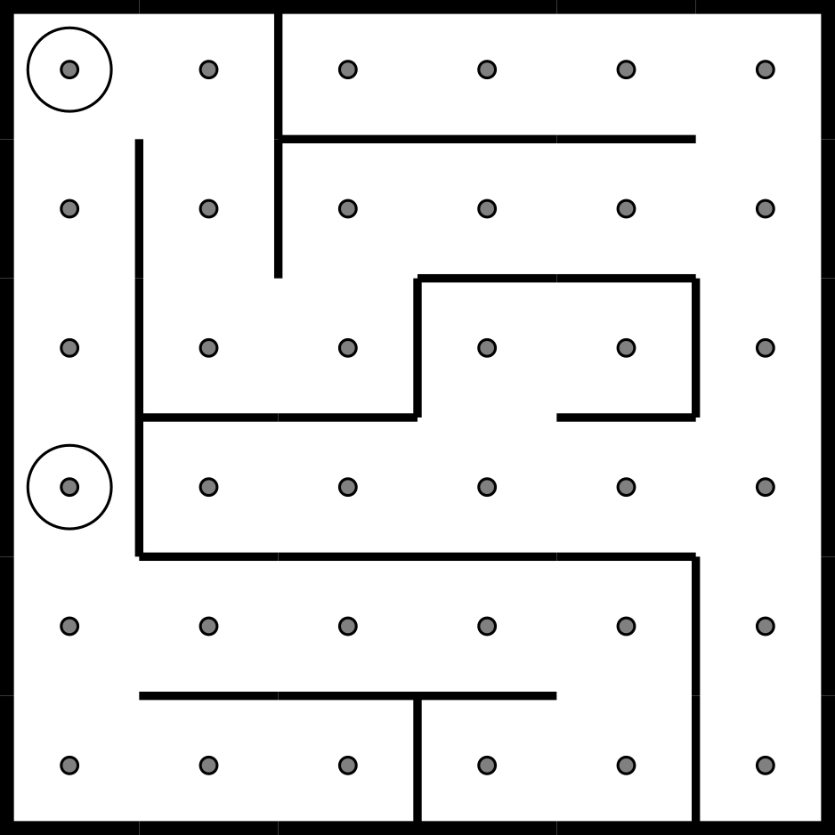 | 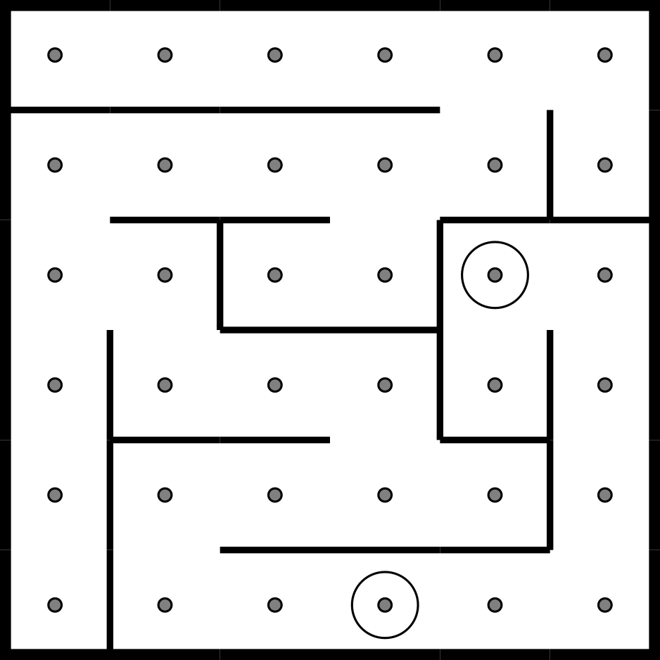 | 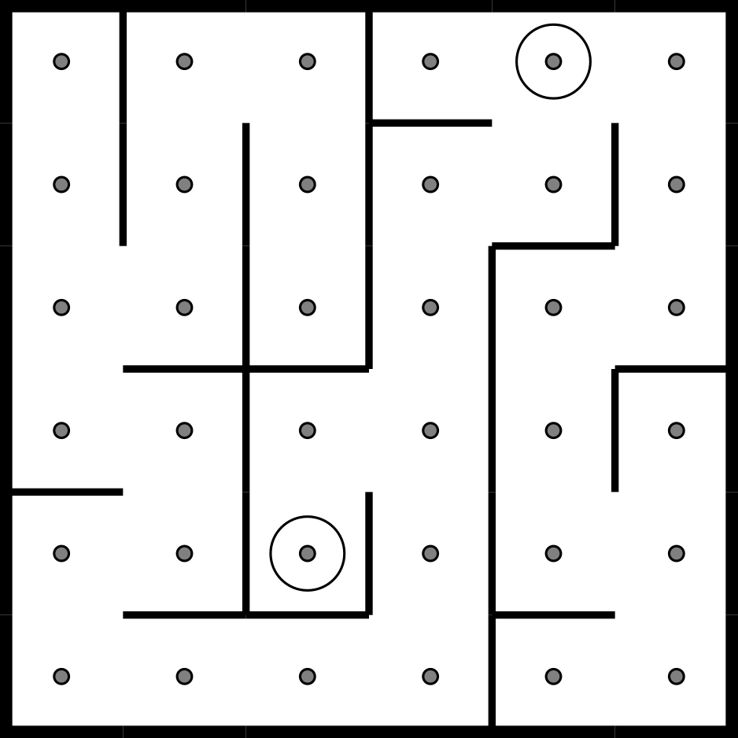
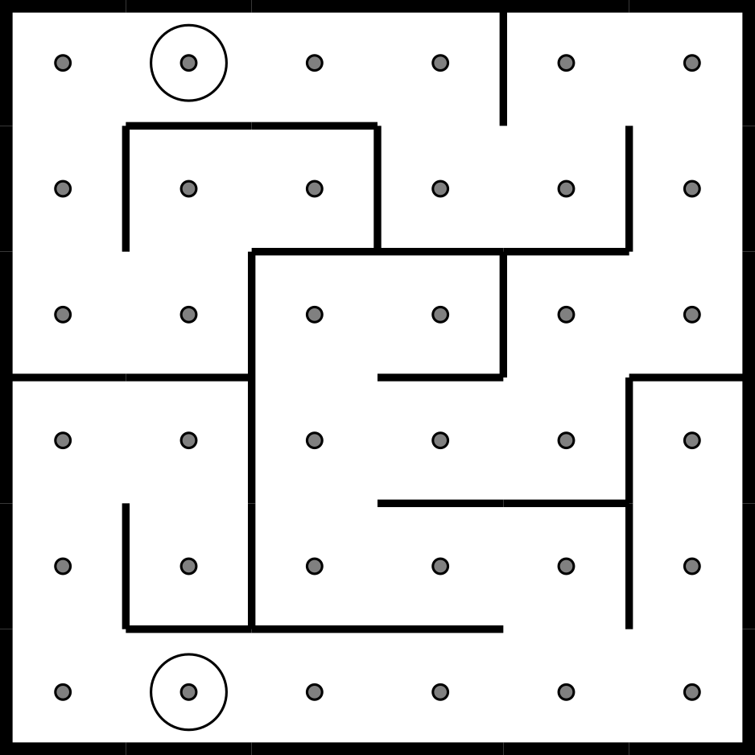 | 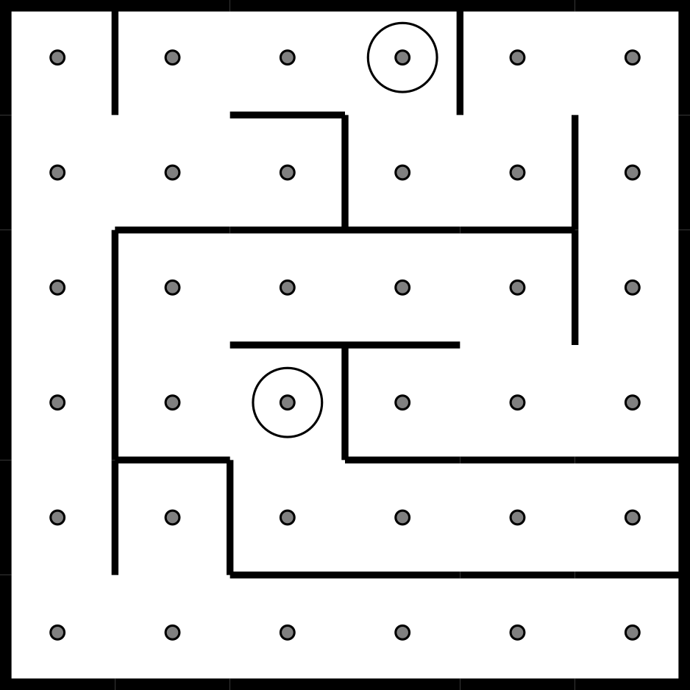 | 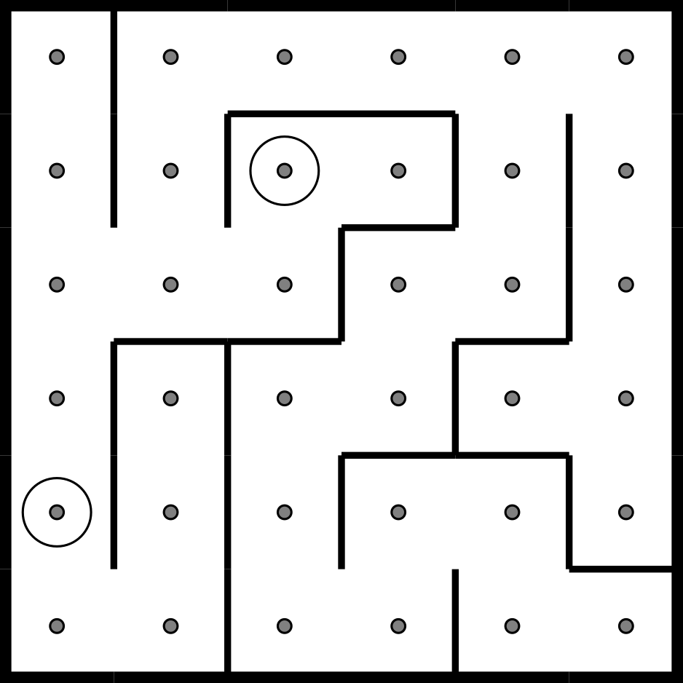

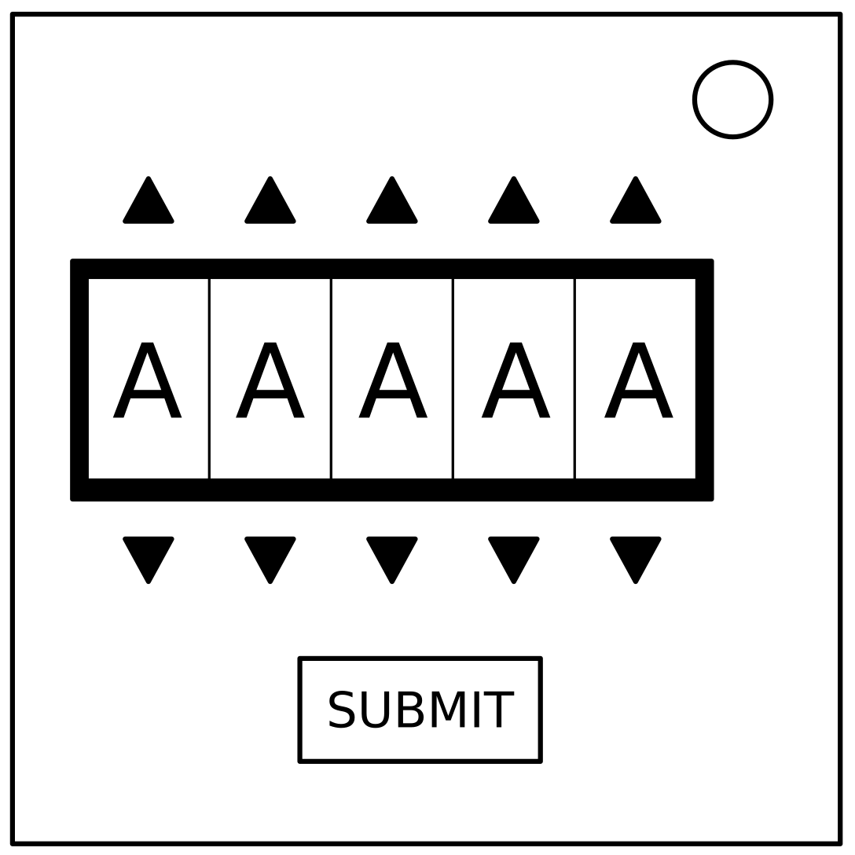
Passwords

- The buttons above and below each letter will cycle through the letter possibilities for that position.
- Only one password below can be made with those letters.
- Press the submit button once the correct word has been set.

about
after
again
below
could
every
first
found
great
house
large
learn
never
other
place
plant
point
right
small
sound
spell
still
study
their
there
these
thing
think
three
water
where
which
world
would
write

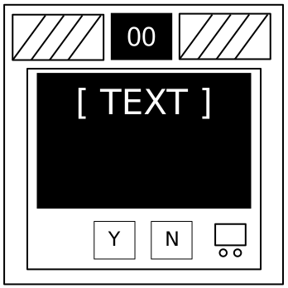
Venting Gas

- Respond to the computer prompts by pressing "Y" for "Yes" or "N" for "No".
- Respond “Yes” if asked to vent gas.

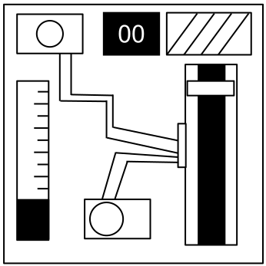

Capacitors
aka capacitor discharge

- The capacitor will continuously charge while defusing the bomb.
- Discharge the capacitor before the timer hits 0 by holding down the lever.

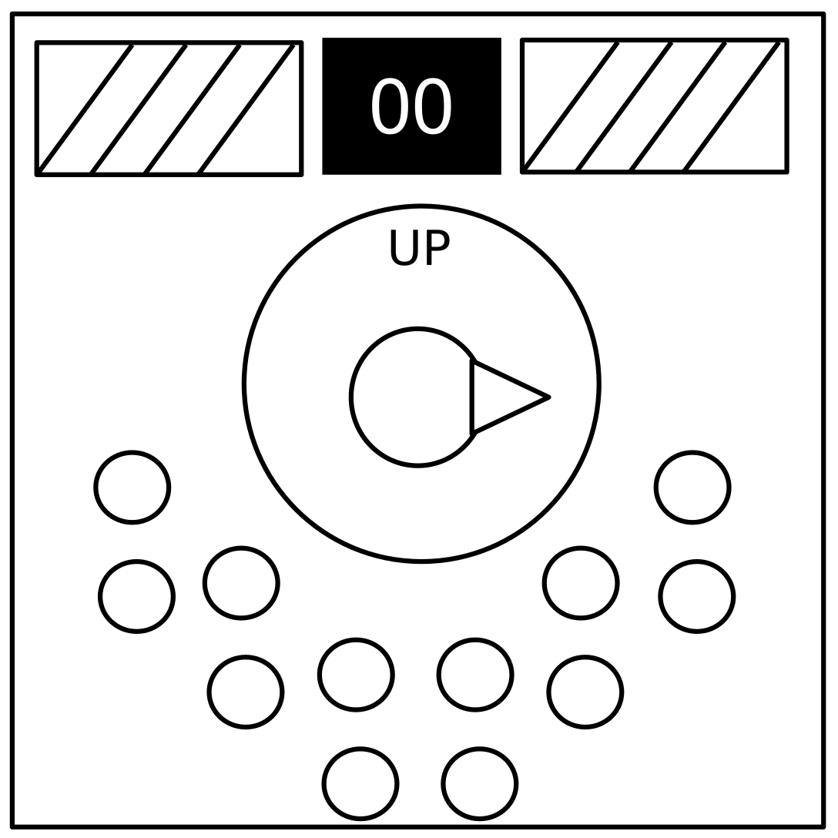
Knobs

Note: This will be updated in a later version of this manual.

- The knob can be turned to one of four different positions.
- The knob must be in the correct position when this module's timer hits zero.
- The correct position can be determined by the on/off configuration of the twelve LEDs.
- Knob positions are relative to the "UP" label, which may have rotated.

LED Configurations
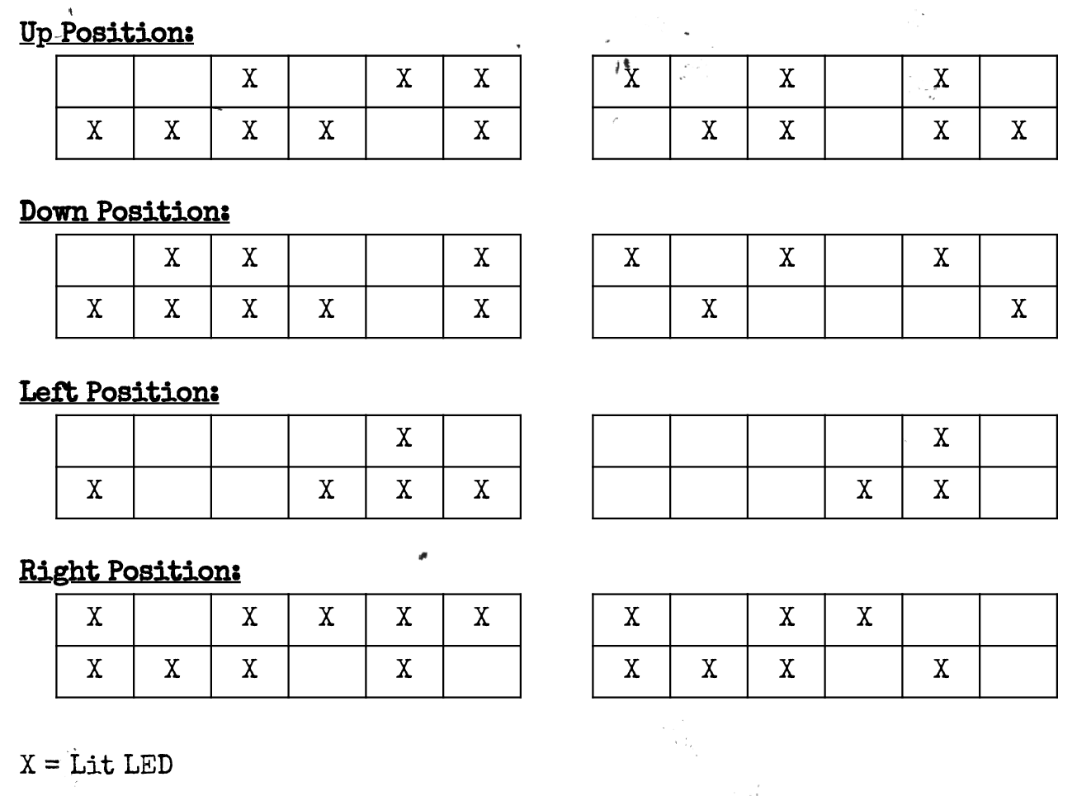

Appendix A: Indicators

Labeled indicator lights can be found on the sides of the bomb casing.

Appendix B: Batteries

Batteries can be found within enclosures on the sides of the bomb casing.
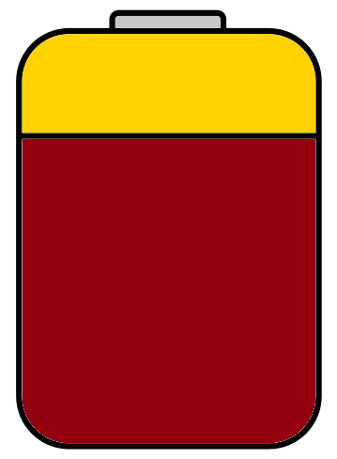
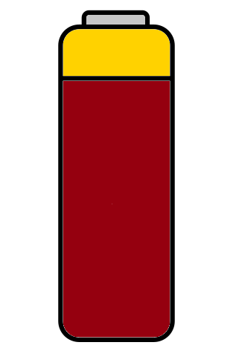

Appendix C: Parallel Ports

Parallel ports can be found on the sides of the bomb casing.

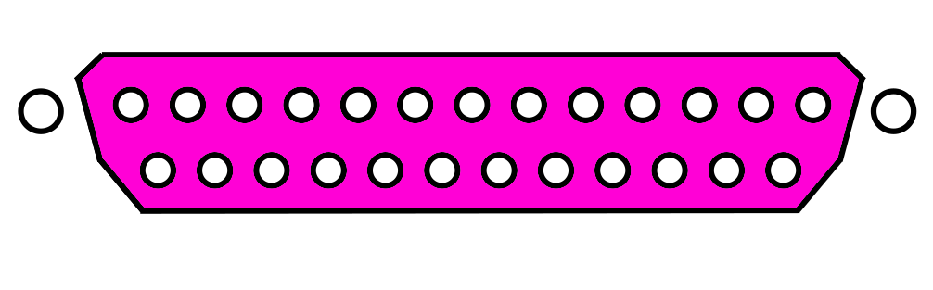

Appendix D: Serial Numbers

Serial numbers can be found on the sides of the bomb casing.

